Using phpMyAdmin in the Azure Server

You have to make a SSH tunnel. This is a process to make the connection more secure. On some servers this is not needed.

1. Open Command Prompt / Terminal.
2. Copy the following line. Change username and IP address:

ssh -N -L 8888:127.0.0.1:80 username@20.54.76.35

1. Hit enter
2. Type "yes" if asked (SSH keys)
3. ...and type your password.
4. Notice that nothing happens, but the tunnel is created.

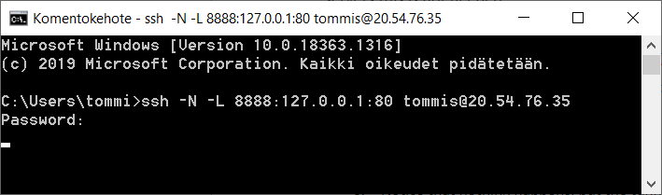

1. Now you can open the browser and type URL of the phpMyAdmin:  
     
   http://localhost:8888/phpmyadmin/

*© Tommi Saksa, HAMK*